**Universidad Politécnica del Valle del Évora**

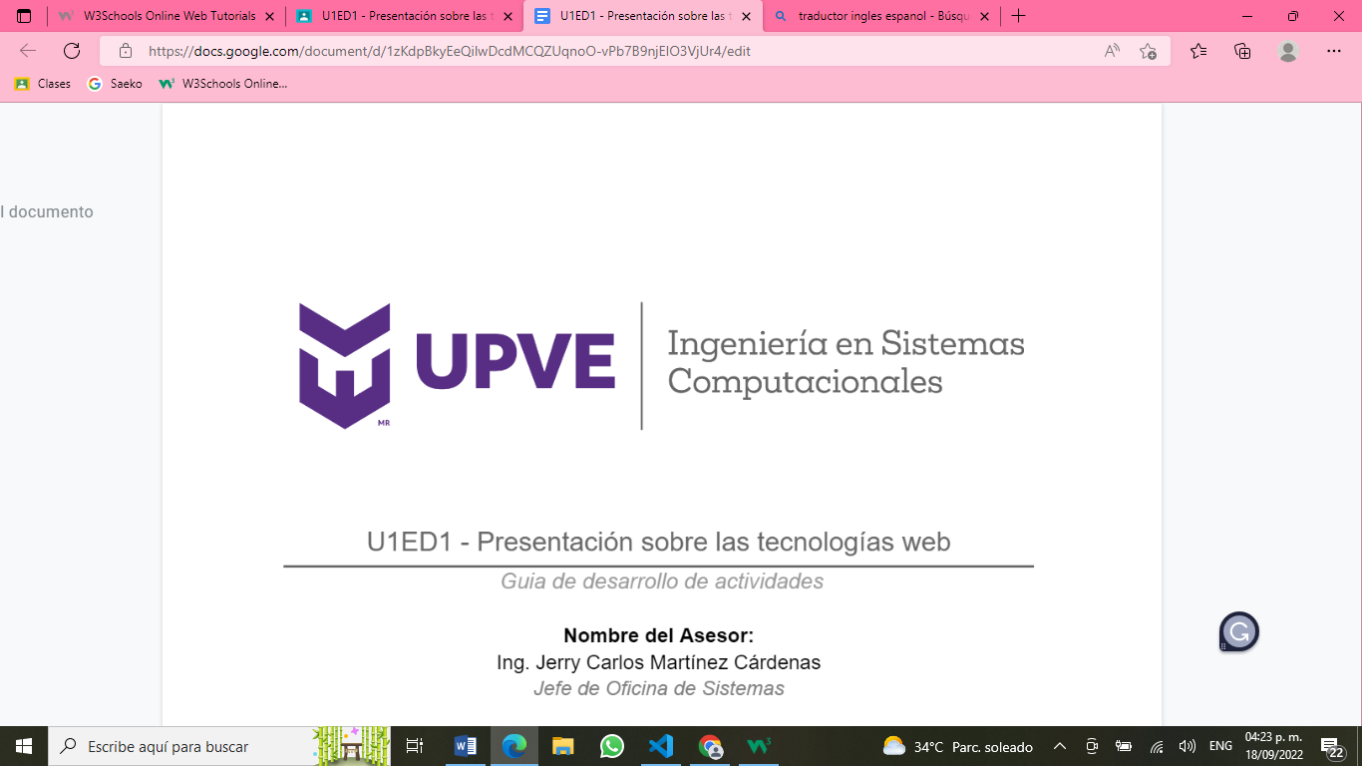

**Ingeniería en Sistemas Computacionales**

**Inglés VII**

**ED1. Realiza una conversación oral en la que se aborde el tema de literatura en el ámbito del estudio y en el tiempo libre.**

**Maestro: Francisco Rene Arámbula Chaidez**

**Alumnas: Enedina Ramírez González (200100072)**

**Kitzia Maybeth Zalazar Castro (200100073)**

**SC7-1**

**Leopoldo Sánchez Celis, Ang, Sin. A 19 de septiembre del año 2022.**

**Conversation in the field of study and free time**

**Enedina:** Hello Kitzia, how are you?

**Kitzia:** Hi Enedina, very good and you?

**Enedina:** Good, I'm fine, tell me what you're doing.

**Kitzia:** I'm glad you're okay, I'm reading a book, what do you do?

**Enedina:** How interesting, I'm leaving work.

**Kitzia:** Seriously? and what do you work on?

**Enedina:** Work installing cameras.

**Kitzia:** That's a very interesting thing.

**Enedina:** If so, what do you work on?

**Kitzia:** Attending a cyber, hey you have a hobby?

**Enedina:** Yes, I like to play Parchis with a friend.

**Kitzia:** How good it should be fun.

**Enedina:** Yes, Kitzia was a pleasure to greet you, see you later.

**Kitzia:** The taste was mine, take care goodbye.

**Enedina:** Goodbye.